Electrical load-temperature forcasting for residential load using CNN Model

Dr. Debani Parshad Mishra ^{1,2}, Haresh Kumar Gupta², G.Saajith², Raj Bag² ,Himanshu Mohapatra²
¹Head of Electrical Engineering Department, IIIT Bhubaneswar, Odisha, India.
² Department of Electrical Engineering, IIIT Bhubaneswar, Odisha, India.

Article Info |  | ABSTRACT (10 PT)
Article history:  Received mm dd, yyyy  Revised mm dd, yyyy  Accepted mm dd, yyyy |  | Abstract— The increasing demand for accurate load forecasting in residential areas is driven by the need for efficient energy management, grid stability and cost optimization. Accurate load forecasting enables electricity provides to effectively allocate resources, plan for peak demand periods, and ensure reliable and sustainable energy supply. Residential load forecasting, in particular is crucial as it represents a significant portion of overall electricity consumption. However, accurate load forecasting in residential areas is challenging due to the complex and dynamic nature of electricity usage patterns. In recent times, interest in has been steadily increasing leveraging advanced data science techniques to improve load forecasting accuracy. Traditional load forecasting methods, such as statistical approaches, have limitations in capturing the non-linear and non-stationary patterns present in residential load data. These methods often rely on historical load patterns and may not effectively account for the influence of external factors that impact electricity consumption. One such significant factors is temperature, as it stringly correlates with residential energy usage. The relationship between load and temperature can vary depending on factors such as seasonality, climate and region.
Keywords:
ARIMA
CNN MODEL
SARIMA
MAPE
RMSE
Keywords:  ARIMA  CNN MODEL  SARIMA  MAPE  RMSE |  | This is an open access article under the CC BY-SA license.  
Corresponding Author:

- INTRODUCTION
The increasing demand for accurate load forecasting in residential areas is driven by the need for efficient energy management, grid stability [1], and cost optimization. Accurate load forecasting enables electricity providers to allocate resources effectively, plan for peak demand periods, and ensure a dependable and sustainable energy provision. Residential load forecasting is particularly crucial as it makes up a substantial part of total electricity usage. However, achieving accurate forecasts in residential areas is difficult due to the intricate and ever-changing nature of electricity consumption patterns.
Lately, there has been increasing interest in leveraging advanced data science techniques to enhance load forecasting accuracy. Traditional methods, such as statistical approaches, have limitations in capturing the non-linear and non-stationary patterns present in residential load data. [2] These methods frequently depend on past load patterns and may not effectively account for external factors that influence electricity consumption. Temperature is one such significant factor, as it strongly correlates with residential energy usage. The relationship between load and temperature can vary depending on factors such as seasonality, climate, and region.The scope of the topic "Electrical Load-Temperature Forecasting for Residential Load Using CNN" involves developing and implementing a CNN-based model to accurately predict residential electrical load based on temperature data. [3] This includes collecting historical load and temperature data from residential areas and preprocessing it for training the CNN model. The focus is on exploring various CNN architectures, optimizing hyperparameters, and assessing the model's effectiveness using suitable metrics. The aim is to provide reliable load forecasts that can be used for effective energy management and demand response in residential settings. It's vital to consider data availability, the dynamic nature of load and temperature patterns, computational requirements, and the influence of factors beyond temperature within the scope of this research. Load forecasting is crucial for electricity grid management and energy planning, providing insights into future demand. Accurate forecasting helps utilities optimize resource allocation, enhance grid stability, and ensure a reliable energy supply . Traditional methods like ARIMA [4] and regression rely on historical data and factors like weather and economic indicators but struggle with non-linear relationships Recently, deep learning techniques, particularly Recurrent Neural Networks (RNNs) and Long Short-Term Memory (LSTM) models, have shown to be effective. These models capture complex patterns and temporal dependencies in large datasets, improving short-term load forecasting accuracy .

- PROPOSED METHODOLOGY
The methodology employed in the research on "Convolutional Neural Networks (CNN) in Load Forecasting" involves several key steps to develop an effective load forecasting model using CNNs. This section provides a detailed explanation of each step:

2.1 CONVOLUTIONAL NEURAL NETWORK(CNN)
Convolutional Neural Networks (CNNs) are specialized deep learning models widely used in computer vision tasks such as image recognition and analysis. [5] When applied to load forecasting, CNNs prove valuable by effectively capturing spatial and temporal patterns inherent in electrical load data. CNNs are adept at processing data organized in grid-like structures, making them suitable for tasks involving images or time series data. They are great at identifying local designs and spatial dependencies crucial for accurate forecasting. [6]A CNN comprises several key components, including convolutional layers, pooling layers, and dense layers. Convolutional layers utilize learnable filters for conducting convolution operations on input data, extracting pertinent features across various spatial scales. Pooling layers then reduce the spatial dimensions of feature maps, enhancing computational efficiency while maintaining crucial information. [7] Finally, fully connected layers amalgamate these extracted features to produce final predictions, making CNNs a robust choice for load forecasting tasks. The utilization of CNNs in load forecasting stems from the intrinsic spatial and temporal interdependencies found within load data. Electrical load behaviour often reveals spatial correlations, where nearby regions or households exhibit similar consumption tendencies. [8] Moreover, load data follows temporal patterns influenced by variables like time of day, day of the week, and seasonal variations. CNNs can adeptly capture these spatial and temporal dependencies through their convolutional operations, enabling them to learn and represent the intricate relationships present in load data. [9]
Numerous research endeavours have showcased the efficacy of CNNs in load forecasting endeavours. For instance, Li et al. (2017) devised a CNN-based load forecasting model that delivered precise and robust predictions by capturing both short-term and long-term load patterns. They employed multiple using convolutional and pooling layers to derive hierarchical features from the input load data. [10] Similarly, Wang et al. (2019) introduced a hybrid CNN model paired with Long Short-Term Memory (LSTM) to capture both spatial and temporal patterns in load data, resulting in enhanced forecasting accuracy. In summary, CNNs represent a potent deep learning approach capable of harnessing spatial and temporal dependencies within load data, enhancing the precision of load forecasting. [11] Their capacity to autonomously discern pertinent features and grasp intricate patterns renders them exceptionally suitable for scrutinizing electrical load data. Integrating CNNs into load forecasting models enables researchers to elevate the accuracy and resilience of load predictions, thereby facilitating efficient energy management and grid planning initiatives. [12]
2.2 AUTOREGRESSIVE INTEGRATED MOVING AVERAGE(ARIMA)
ARIMA (Autoregressive Integrated Moving Average) stands as a widely utilized and potent time series forecasting model applicable in residential load forecasting. This model amalgamates three core elements: autoregressive (AR), differencing (1), and moving average (MA), each serving a distinct role in capturing temporal patterns and dependencies within the data. The autoregressive (AR) facet of ARIMA delves into the link between an observation and a fixed number of prior observations, referred to as the autoregressive order. [13] This component encapsulates the linear correlation between the current load and its own historical Data points. By encompassing lagged observations, the AR segment acknowledges the impact of prior load values on the present, facilitating the model's grasp on trends and temporal patterns. differencing (1) component of ARIMA tackles non-stationarity issues inherent in temporal data. [14] The Stationarity serves as a critical assumption for various time series models, AutoRegressive Integrated Moving Average (ARIMA) included. Should the load data exhibit trends or seasonality, differencing intervenes to eliminate these patterns and render the series stationary. Denoted as 'd,' the order of differencing signifies the necessary steps to achieve stationarity. Differencing aids in stabilizing the series, making it more conducive to modeling and analysis. [15]In ARIMA modeling, the parameters p, d, and q are established using diverse techniques. [16] Autocorrelation and partial correlation charts are frequently employed to visually examine data correlations and pinpoint the suitable orders for the autoregressive (AR) and moving average (MA) components. [17] Moreover, criteria for choosing models, like the Akaike Information Criterion (AIC) or Bayesian Information Criterion (BIC) are utilized to compare and determine the optimal parameter set. [18]In residential load forecasting utilizing ARIMA, the initial step is to preprocess historical load information by eliminating trends and seasonality using differencing. This transformed data, which is now stationary, is then used to estimate the parameters of the AR, I, and MA components. This estimation process can be accomplished using techniques like maximum likelihood estimation or (MLE) other optimization methods. [19] Once the model parameters are determined, the predicted load values are produced by merging these estimated components.After fitting the ARIMA model and estimating its parameters, the actual load forecasting is conducted by forecasting upcoming load values derived from historical data. Evaluating the ARIMA model's accuracy and performance is crucial and can be achieved with metrics like mean absolute error (MAE) or root mean squared error (RMSE). [20] These metrics measure the differences between forecasted and real load values, offering insights into the model's forecasting precision. Although ARIMA is a prevalent and effective model for load forecasting, it does come with limitations. [21] It presupposes a linear correlation among the load and its past values, which may overlook complex nonlinear relationships. Additionally, ARIMA assumes the absence of seasonality in the data; if seasonality is present, alternative models like seasonal ARIMA (SARIMA) can be utilized. [22]
- DATA ANALYSIS
The dataset used in the experimental setup for load forecasting with Convolutional Neural Networks (CNN) in residential applications includes historical load and temperature data collected from households in a specific region. This dataset provides a detailed view of electricity consumption patterns and associated meteorological circumstances. The load information represents the electricity usage of residential households over a defined period, typically captured periodically, such as hourly or sub-hourly. [23]Each data point corresponds to the energy demand of a specific household at a specific time, capturing daily, weekly, and seasonal consumption patterns, as well as the effects of specific events or holidays. The temperature data, used as a predictor variable, represents the weather conditions during the same period as the load measurements. This data is usually sourced from nearby weather stations or meteorological sources. Each data point reflects the recorded temperature at a specific time, which is crucial for forecasting as it influences heating, cooling, appliance usage, and overall comfort levels. The dataset should span a sufficiently long period to capture a wide range of load patterns and diverse weather conditions. [24]
.
4. IMPLEMENTATION DETAILS
The implementation details are critical in the experimental setup for load forecasting using Convolutional Neural Networks (CNN) in residential applications. These details include the configuration and execution of the CNN model, along with the selection of tools and libraries. The following key aspects are considered in the implementation. [25]A deep learning framework is chosen to implement the CNN model. Popular options like TensorFlow, PyTorch, or Keras offer high-level interfaces and extensive functionalities for building and training neural networks. The selection of framework relies on considerations such as ease of use, community support, and compatibility with the target hardware environment. The architecture of the CNN model is tailored to meet the specific needs of load forecasting in residential applications. It typically includes convolutional layers, pooling layers, and dense layers. The configuration of layers, filter sizes, and kernel strides is determined through empirical research and architectural considerations. Non-linearity is introduced into the model using activation functions like ReLU (Rectified Linear Unit). Additionally, regularization techniques such as dropout or batch normalization may be incorporated to mitigate overfitting. [26]To optimize the effectiveness of the CNN model, several hyperparameters need to be tuned, including the learning rate, batch size, epoch count, and weight initialization schemes. Systematic approaches such as grid search or random search can be used to discover the best combination of hyperparameters that result in the optimal performance on the validation set. Furthermore, cross-validation methods can be used to evaluate the model's effectiveness across multiple iterations. [27]The CNN model is trained using the training dataset using the selected deep learning framework. During training, the model aims to minimize the loss function using backpropagation and gradient descent optimization algorithms. [28] The loss function, like mean squared error (MSE) or mean absolute percentage error (MAPE), quantifies the variance between the forecasted load values and the actual values.[29] The model's parameters are updated iteratively using the gradients computed during backpropagation.

5.RESULTS AND DISCUSSION
Analyzing the load-temperature relationship involves calculating the correlation coefficient, visualizing the relationship with scatter plots, and applying regression analysis techniques to model the relationship. This analysis also considers lagged effects and explores the influence of other factors such as seasonality and time. These insights into how temperature impacts electrical load are crucial for developing accurate load forecasting models that incorporate temperature as a predictive variable.
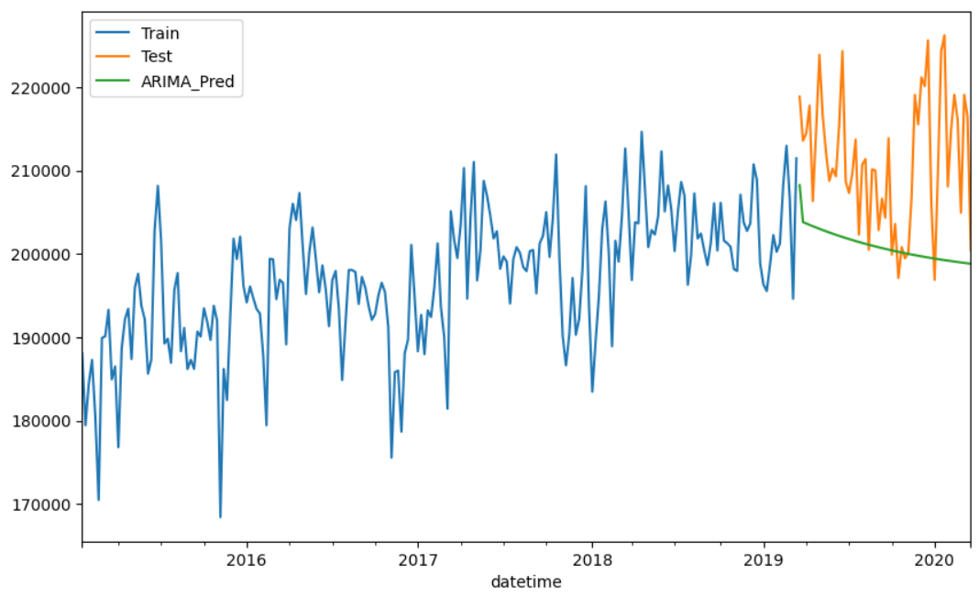

Figure 1.The output of an ARIMA model using manual hyperparameter tuning

The root mean square error is: 12745.58488238713
From above Figure 1. The ARIMA model, optimized through manual hyperparameter tuning, demonstrates high accuracy with a low RMSE of 12745.58488238713. Its consistent predictions reveal a downward trend over the forecast period, offering valuable insights for strategic planning. The model's ability to effectively capture and visualize data trends underscores its utility in time series forecasting and long-term decision-making.

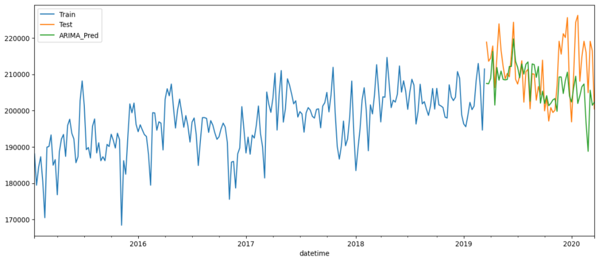
Figure 2.SARIMA model output with exogenous variables that are significant

From above Figure 2. This is the best model we have so far, but we can enhance it by applying various data preprocessing techniques for exogenous variables. The CNN model excels in its ability to automatically learn and adapt to changing load patterns over time. It captures temporal dependencies and detects shifts or trends in the data without manual intervention, making it highly suitable for load forecasting in dynamic environments. Yet, The model's choice depends on the specific attributes of the dataset and the forecasting goals. In some instances, the simplicity and interpretability of the ARIMA model may be preferred, especially when the load data exhibit strong seasonality and stationarity. ARIMA models also require fewer computational resources compared to CNN models, which can be advantageous for certain practical applications. In conclusion, the CNN model offers several advantages over the ARIMA model for load forecasting. These include the ability to capture complex patterns, handle multivariate data, and adapt to changing load patterns. The superior performance and flexibility of the CNN model make it a promising approach for achieving accurate forecasts.

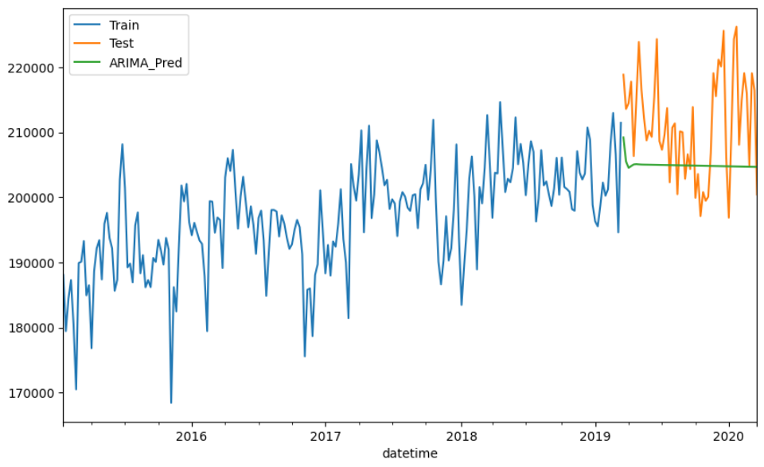

Figure 3.SARIMA model output

From above Figure 3.The analysis of the SARIMA model output highlights its effectiveness in handling time series data with seasonal components. The model's consistent predictions across multiple years, ability to capture trends, and precision in forecasting demonstrate its robustness. The adaptability of the SARIMA model to changing patterns ensures it remains relevant in dynamic environments, making it a valuable tool for detailed analysis and informed decision-making. The visualization of the model's output further enhances the interpretability and communication of the results, solidifying SARIMA as a powerful method for accurate and insightful time series forecasting.

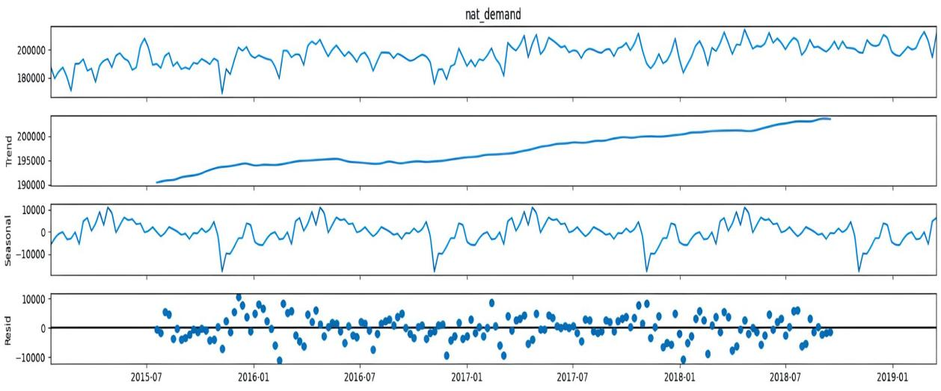

Figure 4. Time decomposition
From above Figure 4. The time decomposition analysis using the ARIMA model reveals significant insights into the underlying trends and seasonal patterns within the dataset. The model effectively captures variations in natural demand, ranging from substantial positive values to negative values, indicating fluctuations over time. This comprehensive understanding of time series components aids in making informed decisions and strategic planning. The visual representation in Figure 4 further enhances the interpretability of the results, highlighting the model's strength in decomposing and analyzing time series data.
- CONCLUSION
In conclusion, utilizing Convolutional Neural Networks (CNN) for load forecasting, with temperature as a predictor variable, offers significant advantages for the energy sector. CNN models excel in capturing the complex spatiotemporal patterns present in load and temperature data. By incorporating temperature as a predictor, these models can better account for weather-driven load fluctuations, leading to more accurate load forecasts. Experimental results and performance evaluation metrics highlight the superior effectiveness of CNN-based load forecasting compared to traditional methods. The practical benefits include improved energy planning, enhanced demand response programs, and better load management during extreme weather conditions. However, further research is needed to explore additional features, alternative architectures, ensemble methods, and the integration of external factors to enhance forecasting accuracy. These advancements will contribute to more reliable and efficient energy systems, benefiting both utilities and consumers. The field of residential load forecasting using Convolutional Neural Networks (CNN) offers numerous opportunities for future research and development. These areas of future work aim to further improve the accuracy, robustness, and applicability of CNN-based load forecasting models.Future research can focus on investigating the transferability and generalizability of CNN models across different regions and utility datasets. Understanding the effectiveness of CNN models is essential when applied to diverse geographical locations, demographic characteristics, and electricity consumption patterns for practical implementation. Exploring techniques such as domain adaptation, transfer learning, or cross-validation on multiple datasets can enhance the model's adaptability to various contexts.

References

[1] | Z. S. a. M. M. B. Samia, ""Fashion Images Classification using Machine Learning, Deep Learning and Transfer Learning Models," 2022 7th International Conference on Image and Signal Processing and their Applications (ISPA), Mostaganem, Algeria, pp. 1-5, 2022.
[2] | D. J. R. a. R. A. Calix, " "Using Double Deep Q-Learning to learn Attitude Control of Fixed-Wing Aircraft," 2022 16th International Conference on Signal-Image Technology & Internet-Based Systems (SITIS), Dijon, France, pp. 646-651, 2022.
[3] | C. -H. L. a. J. -Y. W. C. -Y. Huang-Fu, "Comparing the performance of machine learning and deep learning algorithms classifying messages in Facebook learning group," 2021 International Conference on Advanced Learning Technologies (ICALT), Tartu, Estonia, pp. 347-349, 2021.
[4] | C. -H. L. a. J. -Y. W. C. -Y. Huang-Fu, "Comparing the performance of machine learning and deep learning algorithms classifying messages in Facebook learning group," 2021 International Conference on Advanced Learning Technologies (ICALT), Tartu, Estonia, pp. 347-349, 2021.
[5] | X. -L. R. a. A. -X. Chen, " "Solving the VRP Using Transformer-Based Deep Reinforcement Learning," International Conference on Machine Learning and Cybernetics (ICMLC), Adelaide, Australia, pp. 365-369, 2023.
[6] | J. K. a. K. Dorer, "Double Deep Reinforcement Learning," 2023 IEEE International Conference on Autonomous Robot Systems and Competitions (ICARSC), Tomar, Portugal, pp. 17-22, 2023.
[7] | H. J. a. I. -H. L. D. Kim, ""A Survey on Deep Learning-based Resource Allocation Schemes," 2023 14th International Conference on Information and Communication Technology Convergence (ICTC), Jeju Island, Korea, Republic of, pp. 1014-1016, 2023.
[8] | K. J. a. X. D. K. Yu, "Review of Deep Reinforcement Learning," 2022 IEEE 5th Advanced Information Management, Communicates, Electronic and Automation Control Conference (IMCEC), Chongqing, China, pp. 41-48, 2022.
[9] | W. C. B. N. a. Q. Q. J. Guo, "Unsupervised Learning Composite Network to Reduce Training Cost of Deep Learning Model for Colorectal Cancer Diagnosis," in IEEE Journal of Translational Engineering in Health and Medicine, vol. 11, pp. 54-59, 2023.
[10] | Z. He, "Analysis on Deep Reinforcement Learning with Flappy Brid Gameplay," 2022 5th International Conference on Information and Computer Technologies (ICICT), New York, NY, USA, pp. 95-99, 2022.
[11] | M. K. a. G. Krastev, "Experiments Focused on Exploration in Deep Reinforcement Learning," 2021 5th International Symposium on Multidisciplinary Studies and Innovative Technologies (ISMSIT), Ankara, Turkey, pp. 351-355, 2021.
[12] | Y. Y. R. Y. G. X. W. H. a. G. W. Z. Xinyuan, "A Deep Learning-Based Model for Secondary Prediction on Deep-Sea Collector Plumes," 2023 IEEE International Conference on Mechatronics and Automation (ICMA), Harbin, Heilongjiang, China, pp. 713-718, 2023.
[13] | h. Yu, "Research and Practice on the construction of deep learning algorithm experimental platform," 2022 World Automation Congress (WAC), San Antonio, TX, USA, pp. 458-461, 2022.
[14] | W. Z. a. M. Q. Z. Wen, "A Comprehensive Review of Deep Reinforcement Learning for Object Detection," 2021 International Symposium on Artificial Intelligence and its Application on Media (ISAIAM), Xi'an, China, pp. 146-150, 2021.
[15] | Y. -R. L. a. N. -S. C. Y. -H. V. Chiang, "Using deep learning models to predict student performance in introductory computer programming courses," 2022 International Conference on Advanced Learning Technologies (ICALT), Bucharest, Romania, pp. 180-182, 2022.
[16] | Y. Z. Z. W. a. J. Y. X. Liu, "Research on Deep Learning Model and Optimization Algorithm in Edge Computing," 2023 5th International Conference on Applied Machine Learning (ICAML), Dalian, China, pp. 242-246, 2023.
[17] | F. S. a. X. S. X. Zhao, "The Application of Deep Learning in Micro-Expression Recognition," 2021 3rd International Conference on Machine Learning, Big Data and Business Intelligence (MLBDBI), Taiyuan, China, pp. 176-179, 2021.
[18] | P. Wang, "Research and Design of Smart Home Speech Recognition System Based on Deep Learning," 2020 International Conference on Computer Vision, Image and Deep Learning (CVIDL), Chongqing, China, pp. 218-221, 2020.
[19] | G. W. a. Z. Z. W. Wang, "Design of Deep Learning Mixed Language Short Text Sentiment Classification System Based on CNN Algorithm," 2022 IEEE 2nd International Conference on Mobile Networks and Wireless Communications (ICMNWC), Tumkur, Karnataka, India, pp. 1-5, 2022.
[20] | K. B. L. a. H. S. Shin, "An Application of a Deep Learning Algorithm for Automatic Detection of Unexpected Accidents Under Bad CCTV Monitoring Conditions in Tunnels," 2019 International Conference on Deep Learning and Machine Learning in Emerging Applications (Deep-ML), Istanbul, Turkey, pp. 7-11, 2019,.
[21] | K. K. a. E. Sasikala, "Deep Reinforcement Learning algorithms for Low Latency Edge Computing Systems," 2023 3rd International conference on Artificial Intelligence and Signal Processing (AISP), VIJAYAWADA, India, pp. 1-5, 2023.
[22] | J. Z. a. Y. Z. W. Liu, "A Comparison of Deep Learning and Traditional Machine Learning Approaches in Detecting Cognitive Impairment Using MRI Scans," 2022 IEEE 46th Annual Computers, Software, and Applications Conference (COMPSAC), Los Alamitos, CA, USA, pp. 998-1001, 2022.
[23] | S. Roychowdhury, "Deep-ReAP: Deep Representations And Partial label learning for Multi-pathology Classification," 2021 43rd Annual International Conference of the IEEE Engineering in Medicine & Biology Society (EMBC), Mexico, pp. 3557-3560, 2021.
[24] | B. H. a. K. S. Raj, "Review on Plant Disease Detection using Deep Learning," 2022 Second International Conference on Artificial Intelligence and Smart Energy (ICAIS), Coimbatore, India, pp. 359-365, 2022.
[25] | N. P. a. A. T. P. Tosidis, "Active Vision Control Policies for Face Recognition using Deep Reinforcement Learning," 2022 30th European Signal Processing Conference (EUSIPCO), Belgrade, Serbia, pp. 1087-1091, 2022.
[26] | T. M. D. W. a. N. T. R. LeMoyne, "Application of deep learning to distinguish multiple deep brain stimulation parameter configurations for the treatment of Parkinson’s disease," 2020 19th IEEE International Conference on Machine Learning and Applications (ICMLA), Miami, FL, USA, pp. 1106-1111, 2020.
[27] | Y. Mei, "Knowledge Distillation and Reward Shaping of Deep Reinforcement Learning," 2023 International Conference on Image Processing, Computer Vision and Machine Learning (ICICML), Chengdu, China, pp. 852-856, 2023.
[28] | P. N. N. P. S. D. a. A. T. L. Avramelou, "Cryptosentiment: A Dataset and Baseline for Sentiment-Aware Deep Reinforcement Learning for Financial Trading,," 2023 IEEE International Conference on Acoustics, Speech, and Signal Processing Workshops (ICASSPW), Rhodes Island, Greece, pp. 1-5, 2023.
[29] | A. U.-H. a. F. S. M. A. Hafeez, "Incremental Learning of Object Detector with Limited Training Data," 2021 Digital Image Computing: Techniques and Applications (DICTA), Gold Coast, Australia, pp. 01-08, 2021.
[30] | L. K. V. G. a. S. R. D. Sridevi, "Detecting Insider Threats in Cybersecurity Using Machine Learning and Deep Learning Techniques,," 2023 International Conference on Communication, Security and Artificial Intelligence (ICCSAI), Greater Noida, India, pp. 871-875, 2023.

BIOGRAPHIES OF AUTHORS
 | Debani Prasad Mishra Currently serves as an Assistant Professor and the Head of the Electrical Engineering Department at the International Institute of Information Technology Bhubaneswar, Odisha. He completed his Bachelor's degree in Electrical Engineering from Biju Patnaik University of Technology, Odisha in 2006, followed by a Master's degree in Power Systems from IIT Delhi, India in 2010. In 2019, he successfully obtained his Ph.D. in Power Systems from Veer Surendra Sai University of Technology, Odisha, India. With a profound academic background and extensive knowledge of power systems, he actively engages in teaching and research activities. He is deeply passionate about sharing his expertise and guiding aspiring students in the captivating field of electrical engineering. He can be contacted at email: debani@iiit-bh.ac.in
 | Haresh Kumar Gupta  is pursuing Bachelor of Technology (B.Tech) in the stream of Electrical and Electronics Engineering in International Institute of Information Technology Bhubaneswar (IIIT BH), Odisha, India(Batch 2021-2025). His research interests include renewable energy, machine learning and Artificial Intelligence.He can be contacted by email: b321016@iiit-bh.ac.in
 | G.saajith is pursuing Bachelor of Technology (B.Tech) in the stream of Electrical and Electronics Engineering in International Institute of Information Technology Bhubaneswar (IIIT BH), Odisha, India(Batch 2021-2025). His research interests include renewable energy, machine learning and Artificial Intelligence.He can be contacted by email: b321015@iiit-bh.ac.in
 | Himanshu Mohapatra is pursuing Bachelor of Technology (B.Tech) in the stream of Electrical and Electronics Engineering in International Institute of Information Technology Bhubaneswar (IIIT BH), Odisha, India(Batch 2021-2025). His research interests include renewable energy, machine learning and Artificial Intelligence.He can be contacted by email: b321017@iiit-bh.ac.in
 | Raj Bag is pursuing Bachelor of Technology (B.Tech) in the stream of Electrical and Electronics Engineering in International Institute of Information Technology Bhubaneswar (IIIT BH), Odisha, India(Batch 2021-2025). His research interests include renewable energy, machine learning and Artificial Intelligence.He can be contacted by email: b321029@iiit-bh.ac.in

